The Invasive Grass-Fire Cycle in the U.S. Great Basin

Introduction

People have altered natural fire regimes across landscapes for tens of thousands of years by changing ignitions and fuels (Pyne 2001). In the last couple hundred years, people have even altered the plant species that make up those fuels. One remarkable feedback is the introduction of invasive grass species across continents which then changes fire activity. This process is termed a novel ‘grass-fire cycle’ (D'Antonio and Vitousek 1992).

In the western U.S., cheatgrass (Bromus tectorum) has invaded the Great Basin biome. Introduced in the mid-1800s, this single species with origins in north Africa and the Middle East, now dominates 20,000 km² (Bradley and Mustard 2005). The large-scale presence of cheatgrass has altered natural fire regimes, particularly in sagebrush and salt desert shrub ecosystems (Whisenant 1990, Chambers et al. 2007). Yet, despite these substantial effects, to date only a few studies have documented altered fire cycles at local scales, and the availability of satellite data opens the door to explore this question at larger regional scales.

Climate-driven changes in biome boundaries have already been predicted for the Great Basin (Bradley 2009, Chambers and Wisdom 2009) and fire and species invasions can accelerate these transitions (Haubensak et al. 2009). Therefore, the goal of this exercise is to investigate how non-native grasses can alter natural fire regimes.

i. Background

Frontier expansion has been a vehicle for the introduction and spread of invasive species (Mack 1981). Further, altered fire regimes have accompanied the expansion of frontiers. Fire has been used as a tool in the transformation of landscapes for agriculture and cattle pasture. Alternatively, fire suppression and grazing has set the stage for species invasion and future surges in fire activity. One important feedback has been a new fire regime that is driven by high levels of non-native grass fuel and high ignitions from people. Once initiated, this invasive grass-fire cycle is difficult to halt or reverse (D'Antonio and Vitousek 1992, Brooks et al. 2004). This phenomenon has occurred and continues to occur across continents, from Eurasia to Oceania, from Africa to South America, including the western U.S.

Cheatgrass was accidentally introduced to the Great Basin by settlers in the mid-1800s. This drought-tolerant grass creates a more continuous fuel bed than existed previously and cures earlier than native perennial grasses (Whisenant 1990, Chambers et al. 2007), potentially extending the fire season and contributing to more frequent and larger fires. This disruption to the native fire regime is often cited as a classic example of an invasive grass-fire cycle. One study from Snake River Plains in Idaho documents the actual shift in fire frequency caused by cheatgrass (Whisenant 1990). We will explore this study in detail in one of the following exercises.

The U.S. Great Basin covers 450,000 km², 80% of which is publicly owned. This semi-arid region encompasses shrublands, grasslands, and montane forests. Native Americans managed the landscape with fire (Pyne 1982). Yet, frontier expansion brought a new fire regime with ongoing legacies. Frontier settlement introduced sheep grazing, which subsequently reduced native perennial grasses; this led to senescent stands of sagebrush and consequently opened up opportunities for invasion. There has since been over a 100-year lag between this phase of frontier settlement and the substantial increase in fire frequency witnessed today. In the past few decades, fire frequency in sagebrush ecosystems has increased from every 60–110 years to 3–5 years with the increase in invasive annual grasses (Whisenant 1990).

The legacy of frontier development and agricultural expansion is an altered landscape, with combined pressures from climate change, invasive species, and altered ignitions. In recent decades, the western U.S. has been subject to severe drought conditions that have increased fire activity (Westerling et al. 2006) and tree mortality (van Mantgem et al. 2009).

ii. Objectives

The major questions of this exercise are: i) how do invasive grasses alter natural fire regimes? and ii) what are the possible mechanisms that enable invasive grasses to change fire cycles?

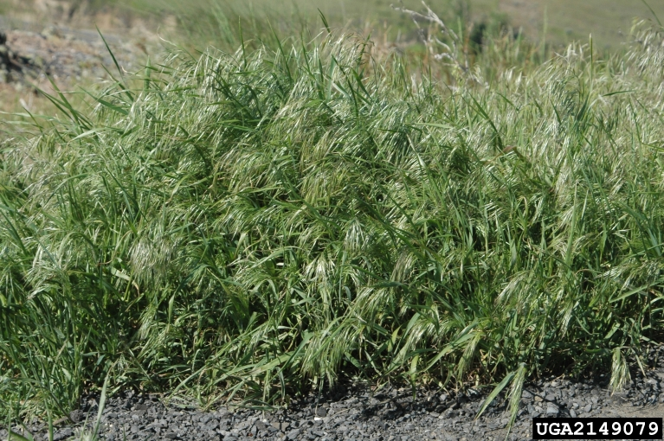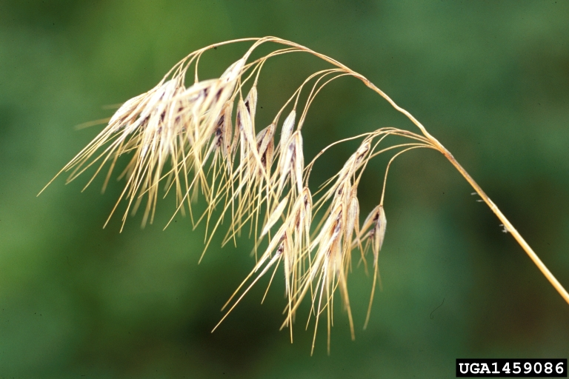
Images 1 and 2: Bromus tectorum up-close by Chris Evans (left) and Steve Dewey (www.invasive.org).

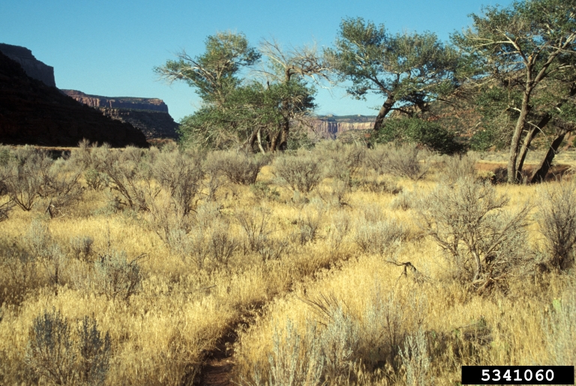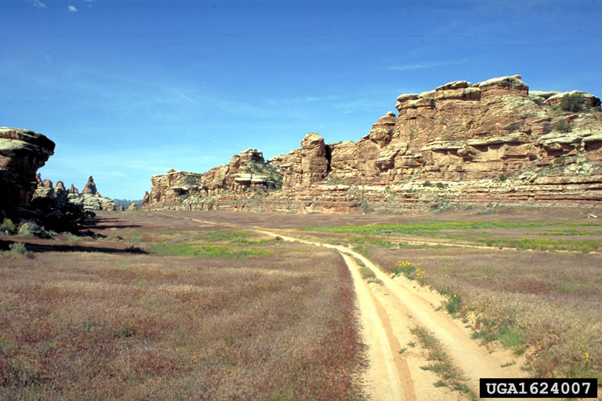
Images 3 and 4: Bromus tectorum infestation by John M. Randall (www.invasive.org).

Dataset descriptions

i. Snake River Plains data

Data from the Snake River Plains on fire frequency, fuel characteristics, and species that make up those fuels are provided from a paper published by Whisenant in 1990. See the original paper for a description of the sampling methods and a description of the site locations. The data file can be opened and analyzed in the Excel sheet (students.xlsx).

ii. MODIS burned area product

NASA has a satellite called the Moderate Resolution Imaging Spectroradiometer, or MODIS, which produces a global burned area product. The MODIS monthly burned area product is a geotiff file that gives information on whether or not each 500-m pixel burned within a given month, or a code indicating snow, water, or lack of data.

There are five files that will be used for this exercise, which have already been clipped and projected in a standard projection (NAD_1927_UTM_Zone_11N). They have also been resampled, so the pixel size matches the cheatgrass landcover map below. There is one file for each month: May-September 2005.

Files:

May 2005: monthly_bd_UTMClip_A2005121.tif
June 2005: monthly_bd_UTMClip_A2005152.tif
July 2005: monthly_bd_UTMClip_A2005182.tif
August 2005: monthly_bd_UTMClip_A2005213.tif
September 2005: monthly_bd_UTMClip_A2005244.tif

The values of the numbers in the file indicate the following:

0 = unburned
1-366 = approximate Julian day of burning
900 = snow or high aerosol
9998 = water bodies, internal
9999 = water bodies, seas and oceans
10000 = not enough data to calculate

iii. Cheatgrass Distribution Map

This unpublished cheatgrass map is from a single MODIS scene of northern Nevada. The projection is the same as for the MODIS burned area product. This classification was done by Bethany Bradley using methods similar to the map produced for Bradley and Mustard (2008). This map is based on inter-annual variability in cheatgrass phenology between 2002-2005 springs. (Phenology is the scientific study of periodic biological phenomena, such as flowering, leaf changes, etc., in relation to climatic conditions.) The map detects 75% of cheatgrass 'presence' points with a 20% false positive rate. Overall accuracy is around 78%.

File: cheatgrass_map.tif

The values of the numbers in the file indicate the following:

0 = no cheatgrass
1 = cheatgrass presence

iv. State Outlines of Western USA

This shapefile gives the state outlines for the western USA region of interest. Projection matches the cheatgrass map and MODIS burned area product.

File: WesternUSA_ProjectUTM.zip

v. Vegetation classification of the U.S. Great Basin

This shapefile contains the classification map derived by Bradley and Mustard (2008) and is used in the optional third lab.

The values in the GRIDCODE are for the following CLASS vegetation types:

1 – Agriculture
2 – Non-vegetated
3 – Montane Shrub/grass
4 – Pinyon-Juniper
5 – Alkali Meadow
6 – Salt Desert Shrub
7 – Cheatgrass
8 – Sagebrush Shrub

File: decision_tree_classification_avhrr_utm.zip

References:

Bradley, B. A. 2009. Regional analysis of the impacts of climate change on cheatgrass invasion shows potential risk and opportunity. Global Change Biology 15:196-208.
Bradley, B. A., and J. F. Mustard. 2008. Comparison of phenology trends by land cover class: a case study in the Great Basin, USA. Global Change Biology 14:334-346.
Brooks, M. L., C. M. D'Antonio, D. M. Richardson, J. B. Grace, J. E. Keeley, J. M. DiTomaso, R. J. Hobbs, M. Pellant, and D. Pyke. 2004. Effects of invasive alien plants on fire regimes. Bioscience 54:677-688.
Chambers, J. C., B. A. Roundy, R. R. Blank, S. E. Meyer, and A. Whittaker. 2007. What makes Great Basin sagebrush ecosystems invasible by Bromus tectorum? Ecological Monographs 77:117-145.
Chambers, J. C., and M. J. Wisdom. 2009. Priority Research and Management Issues for the Imperiled Great Basin of the Western United States. Restoration Ecology 17:707-714.
D'Antonio, C. M., and P. M. Vitousek. 1992. Biological invasions by exotic grasses, the grass-fire cycle, and global change. Annual Review of Ecology and Systematics 23:63-87.
Haubensak, K., C. D'Antonio, and D. Wixon. 2009. Effects of fire and environmental variables on plant structure and composition in grazed salt desert shrublands of the Great Basin (USA). Journal of Arid Environments 73:643-650.
Mack, R. N. 1981. Invasion of Bromus tectorum into western North America - An ecological chronicle. Agro-Ecosystems 7:145-165.
Pyne, S. J. 1982. Fire in America. University of Washington Press, Seattle, Washington.
Pyne, S. J. 2001. Fire: A brief history. Univ. of Washington Press, Seattle.
van Mantgem, P. J., N. L. Stephenson, J. C. Byrne, L. D. Daniels, J. F. Franklin, P. Z. Fule, M. E. Harmon, A. J. Larson, J. M. Smith, A. H. Taylor, and T. T. Veblen. 2009. Widespread increase of tree mortality rates in the western United States. Science 323:521-524.
Westerling, A. L., H. G. Hidalgo, D. R. Cayan, and T. W. Swetnam. 2006. Warming and earlier spring increase western US forest wildfire activity. Science 313:940-943.
Whisenant. 1990. Changing ﬁre frequencies on Idaho’s Snake River plains: ecological and management implications. Symposium on cheatgrass invasion, shrub die-off, and other aspects of shrub biology and management. Intermountain Research Station, Ogden, UT, Las Vegas, NV.

Exercise 1: Data Exploration and Analysis: Snake River Plains Data

In this section, we will explore the relationship between cheatgrass and fire behavior from data published in the research paper by Whisenant (1990) from sites in Idaho’s Snake River Plain. You will need to open the excel file in order to complete this exercise.

Figure: Snake River Plain in Idaho.
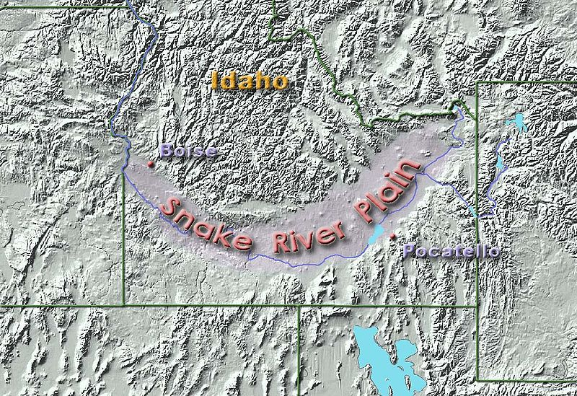

PART I: Relationship between fire frequency and fine fuel cover.

Questions:

- What methods did Whisenant use to calculate fire frequency and fine fuel cover?

- What relationship do you expect between fire frequency and fine fuel cover? How do you think fine fuel cover relates to fuel continuity?

- Test your predicted relationship from question #2 given the data provided in the Excel spreadsheet. Try plotting the data. What conclusions can you draw?

- Do you expect cheatgrass to increase or decrease fuel continuity compared with the fuel structure of native plant species and how then will it change how fire spreads?
PART II: Effect of cheatgrass on fuels and fire behavior

Questions:

- Given the data provided, does cheatgrass dominance change fuel properties that might influence fire frequency? Create a graph to support your answer.

- Given the answer to the question above, how do you think cheatgrass dominance will change fire frequency? Given the data, how does cheatgrass dominance change average fire frequency? Create a graph to support your answer.

- How many years will it take to have a fire in cheatgrass dominant areas vs. other areas? (Note, this estimate roughly matches Whisenant’s estimate of fire return interval.)

- Do native perennial bunchgrasses differ from the annual invasive grass in characteristics related to fire ecology? Create a graph to support your answer. In the Snake River Plain, what factor has the greatest effect on fire frequency?
Exercise 2: Data Visualization and Processing in ArcGIS (version 9.3): MODIS burned area and Cheatgrass Satellite Data

- Data import
  - Add Raster layers of MODIS burned area data for May-September 2005, May file: monthly_bd_UTMClip_A2005121.tif (5 data layers)
  - Add cheatgrass classification map layer, file: cheatgrass_map.tif (1 data layer)
  - Add western USA shapefile, file: WesternUSA_ProjectUTM.zip

- Reclassify MODIS burned area data

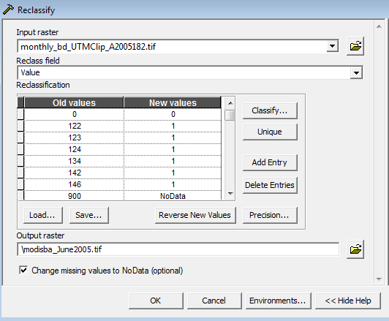

  - Spatial Analyst Tools > Reclass > Reclassify
    - Input raster: a single month of MODIS burned area data
    - Reclass field: Value
    - Click Unique values
    - Input New values so that 0 = unburned, 1 = burned pixel, and NoData = invalid or no data (use metadata below)

MODIS burned area pixel information:
Original MODIS data | New values | Definition
0 | 0 | unburned
1 to 366 | 1 | approximate Julian day of burning
900 | NoData | snow or high aerosol
9998 | NoData | water bodies, internal
9999 | NoData | water bodies, seas and oceans
10000 | NoData | not enough data to calculate

    - Output raster: save as a new .tif file in your file folder (e.g., “modisba_May2005.tif”)

- Using Zonal statistics, calculate by month the number of burned area pixels in cheatgrass and non-cheatgrass zones
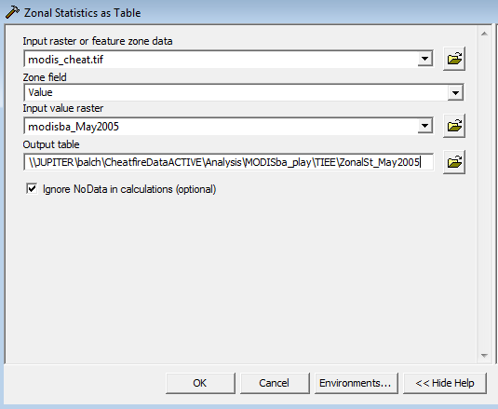

  - Spatial Analyst Tools > Zonal > Zonal Statistics as Table
    - Input raster: cheatgrass map (cheatgrass_map.tif)
    - Zone field: Value (will therefore calculate by 0 and 1 in cheatgrass map)
    - Input value raster: reclassified MODIS burned area data (e.g., modisba_May2005.tif)
    - Output table: name table, e.g., ZonalSt_May2005
    - Check box to Ignore NoData in calculations
    - Open table you just created, SUM column will give you the sum of burned pixels in cheatgrass (1) and no-cheatgrass (0) zones

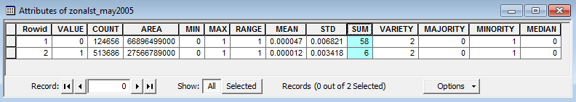

    - Repeat zonal statistics for each month and create a table in Excel that gives the number of burned pixels by month for May – September 2005 for areas where there is and is not cheatgrass.

Data Exploration and Analysis: MODIS burned area and Cheatgrass Satellite Data

Using the data table that you created in Excel, answer the questions below.

Questions:

- How does cheatgrass influence the amount of burning during the fire season of 2005? And how does this compare to the no-cheatgrass areas? Does your answer change if you consider the proportion of the total area that cheatgrass covers? Create graphs to support your answer.

- Does cheatgrass alter the peak timing of fires? Does it alter the fire return interval? Fire return interval is defined as the number of years it would take to burn the entire area.

- How does the fire return interval for cheatgrass and no-cheatgrass compare with what Whisenant estimates for how cheatgrass changes fire return intervals in Idaho’s Snake River Plain? Why might these estimates be different? What general conclusion do both sets of data support?

Exercise 3: Advanced GIS Lab: Modis Burned Area & U.S. Great Basin Landcover Map

Now that you have explored how cheatgrass alters fire activity in relation to non-cheatgrass areas, we are going to explore the differences in fire activity across vegetation types. Using the Bradley and Mustard (2008) landcover map of the U.S. Great Basin (decision_tree_classification_avhrr_utm.zip), we will explore how fires in cheatgrass, sagebrush, pinyon-juniper, montane shrub, and salt desert shrub vegetation types. Using the previous lab as a model for processing steps in ArcGIS, answer the following questions:

- Explore images of these different vegetation types on the web, and describe how the fuel properties look the same or different? For example, see http://www.fs.fed.us/rm/reno/research/ecosystems/

- What is the effect of vegetation type on the fire regimes in the US Great Basin?

- If the U.S. Great Basin experiences a substantial drought year, do you think fire activity would increase or decrease? If we did our calculations of fire return interval based on that drought year, how would that change our estimates?

Synthesis Questions

In-class (after Lecture 1): Think-Pair-Share

Think for a minute or two about these questions, then turn to your nearest neighbor and discuss. Last we’ll discuss as a class what you think the answers are.

- How do you expect cheatgrass to change fuels (e.g., mass, continuity, etc.)?
- Then, how might cheatgrass change the fire regime?

In-class (after Lab Exercise Part II): The minute paper

Answer in one minute this two-part question on a 3x5 notecard or piece of paper. Put your answer to the first question on one side of the card, and your answer to the second on the other side. Please do not sign your name, as this will be anonymous. We will discuss a few of the responses in class.

What did you find to be most interesting or meaningful (write that on one side of the card)? What was the most confusing part (write that on the other side of the card)?

Take-home: Write a 1-2 page essay on one of the following questions

- How many different types of data were used in this project? What are some of the differences and similarities in interpretation between field-based data and regional satellite data? Can you identify other sources of fire data that might be available for use to explore questions about how invasive species change fire activity?

Try exploring some of these sites:

MODIS active fire detections: http://modis-fire.umd.edu/Active_Fire_Products.html

Monitoring Trends in Burn Severity: http://mtbs.gov/nationalregional/intro.html

USDA Forest Service: http://activefiremaps.fs.fed.us/googleearth.php

- What components do you need to start a fire? What controls how fast, how hot, and how far a fire will burn? How can invasive grass species change fire behavior? Be specific. Choose one or two properties of fire behavior such as fire frequency, fire intensity, or fire spread rate.

